**CERTIFICATE**

**This is certify that the following students has successfully and satisfactorily completed and submitted the project.**

**Online Grocery Shop**

**In partial fulfillment of final year diploma course in Computer Science and Engineering prescribed by Maharashtra State Board of Technical Education for academic year 2021-2022.**

**Project Guide External**

**H.O.D Principal**

**ACKNOWLEDGEMENT**

It was highly eventful at the department of Computer Science & Engineering, (…collage name….), Solapur. We would sincerely like to thank our guide Mr/Ms(……..). giving us suggestions and taking a lot of interest in this project and whose advice and guidance helped us a lot. He has always been a source of inspiration for us right from feasibility of the Project.

We would like to thank Mr/Ms(……….) Head of Department and faculty of Computer Science and engineering for spending their valuable time for our Project, we are thankful for their guidance, encouragement and valuable suggestions which help us a lot enhancing our Project.

Lastly we are grateful to those people who directly and indirectly helped us during our Project work.

**ABSTRACT**

**Abstract of the Project Online Grocery Shop :**

**This project is a web based online Grocery Shop shopping system for an existing shop. The project objective is to deliver the online shopping application into android platform.**

**This project is an attempt to provide the advantages of online shopping to customers of a real shop. It helps buying the products in the shop anywhere through internet by using an android device. Thus the customer will get the service of online shopping and home delivery from his favorite shop. This system can be implemented to any shop in the locality or to multinational branded shops having retail outlet chains.**

**If shops are providing an online portal where their customers can enjoy easy shopping from anywhere, the shops won’t be losing any more customers to the trending online shops such as flipcart or ebay. Since the application is available in the Smartphone it is easily accessible and always available.**

**CONTENTS**

PROJECT PEPORT 1

CERTIFICATE 2

ACKNOWLEDGEMENT 3

ABSTRACT 4

INDEX

**TOPIC Page No**

1.1Introduction……………………………………… …….

1System Requirement…………………………………...

Hardware Requirement:

Software requirements..

About The Microsoft Visual Studio……………… ……… ..

Data Flow Diagram…………………………………..……

Flow chart……………………………………………..

ER Diagram……………………………………….…

Features……………………………………

Software testing…………………………...

Coding………………………………….…

Output screen………………………………..

Conclusion …………………………………

**INTRODUCITON**

In this study, the developers develop an online grocery shop that will minimize all the effort and time of the customer and to minimize roaming around as well. Therefore, it allows administrator to track the order of the customer so that they can prepare for it and deliver if needed. Furthermore, in this study, the developer shall create the system that is fully computerized, user-friendly, time effective and well-organized.

Functionality of the system:

* Online Registration for Customers
* Login System for user, customers and managers
* Online catalog, Shopping cart and Checkout and Payment option
* user Dashboard and Inventory Management

The document includes the following topics:

* Preface
* Introduction of the Study
* Statement of the problem
* Current state of technology
* Objectives of the Study (General and Specific Objectives)
* Scope and Limitation of the Study
* Development Tools
* Entity Relationship Diagram

**System Requirement**

Hardware Requirement:

* Processor : Pentium 4 or above.
* Hard disk : 50GB
* RAM : 512 MB or more

Software requirements:

* Operating System : Windows 7/Windows 10
* User Interface : Microsoft Visual Studio
* Database : Microsoft SQL

**About The Microsoft Visual Studio**

**Front End-**

|  |  |  |  |  |  |  |  |  |  |
| --- | --- | --- | --- | --- | --- | --- | --- | --- | --- |
| |  |  | | --- | --- | | **Paradigm** | **Structured, imperative, object-oriented, declarative, generic, reflective and event-driven** | | **Designed by** | **Microsoft** | | **Developer** | **Microsoft** | | **First appeared** | **2001** | |  |

**History of VB.NET :**

* VB.NET is a multi-paradigm programming language developed by Microsoft on the .NET framework. It was launched in 2002 as a successor to the Visual Basic language. This was the first version of VB.NET (VB.NET 7.0) and it relied on .NET version 1.0.
* In 2003, the second version of VB.NET, VB.NET 7.1, was released. This one relied on .NET version 1.1. This version came with a number of improvements including support for .NET Compact Framework and an improved reliability and performance of the .NET IDE. VB.NET 2003 was also made available in the academic edition of Visual Studio.NET and distributed to various scholars from different countries for free.
* In 2005, VB.NET 8.0 was released. The .NET core portion was dropped from its name so as to distinguish it from the classical Visual Basic language. This version was named Visual Basic 2005. This version came with many features since Microsoft wanted this language to be used for rapid application developers. They also wanted to make it different from C# language. Some of the features introduced by this version of VB.NET included partial classes, generics, nullable types, operator overloading, and unsigned integer support. This version also saw the introduction of the IsNot operator.
* In 2008, VB 9.0 was introduced. This was released together with .NET 3.5. Some of the features added to this release of VB.NET included anonymous types, true conditional operator, LINQ support, XML literals, Lambda expressions, extension methods, and type inference.
* In 2010, Microsoft released VB 2010 (code 10.0). They wanted to use a Dynamic Language Runtime for this release, but they opted for co-evolution strategy shared between VB.NET and C# to bring these languages closer to each other.
* In 2012, VB 2012 (code 11.0) was release together with .NET 4.5. Its features included call hierarchy, caller data, asynchronous programming with "await" and "async" statements and the "Global" keyword in the "namespace" statements.
* In 2015, VB 2015 (code 14.0) was released alongside Visual Studio 2015. The "?." operator was introduced to do inline null checks. A string interpolation feature was also introduced to help in formatting strings inline.
* In 2017, VB 2017 (code 15.0) was introduced alongside Visual Studio 2017. A better way of organizing source code in just a single action was introduced.

**VB.NET Features :**

VB.NET comes loaded with numerous features that have made it a popular programming language amongst programmers worldwide. These features include the following:

* VB.NET is not case sensitive like other languages such as C++ and Java.
* It is an object-oriented programming language. It treats everything as an object.
* Automatic code formatting, XML designer, improved object browser etc.
* Garbage collection is automated.
* Support for Boolean conditions for decision making.
* Simple multithreading, allowing your apps to deal with multiple tasks simultaneously.
* Simple generics.
* A standard library.

**D ATA FLOW DIAGRAM:**

**Level 0 DFD:**

**Home**

**Feature**

**Product**

User

**Catrgories**

**Feedback**

**Level 1 DFD:**

**Feedback Selection**

**Tbl_Contact**

**Feedback**

**Tbl_Product**

**Product**

**Product Selection**

**Registration Section**

**Registrartin**

**Tbl_Registration**

Flow chart:

**Registration**

**Dashbord**

**Home**

**Feature**

**Product**

**Categories**

**Feedback**

**Logout**

**ER DIAGRAM:**

Password

User name

USER

LOGIN

do

Registration

DO

Ph_no

F_name

Email

L_name

goto

vegitable

Password

Product Category

HOME

Fresh Fruits

Pulse

Dry fruits

LOGOUT

do

Product

Product rating

Product price

Production

WORK

Feed Back

**Feature**

message

Name

Easy_Payment

Email_id

do

Print

Cart

Product_Qunatity

Product_name

Total

Price

**Features of Online Grocery Shop:-**

**SCOPE**

The purpose of the Project Office Automation System (OAS) is to construct an application that can simplify operations in the college office. Using this, it is possible to maintain a database of college records, such as information about students enrolled in different classes, employee information in different departments, staff and non-staff descriptions, etc. The transaction containing payments and wages is also held Receipts of fees are provided for students Reports are preserved for future use. The search engine is used to search for the necessary details

Use of Office automation system

The purpose of this project is to simplify the work of the office. The existing procedure in the workplace is a manual system that requires a paper sheet. It is very difficult to keep track of all the information in such a system The purpose of our project is to develop an application that will automate processes in a college office.

**Software Testing**

**The purpose of system is to considered all the likely variation to which it will be suggested and push system to limits.**

**The process focuses on the logic intervals of these**

**Software ensuring that all the statements have been tested and on functional interval is conducting test to uncover error and ensure that defined input will produce actual result that agree with the required result program level testing, modules level testing integrated and carried out.**

**There are major types of testing:**

**WHITE BOX TESTING**

**BLACK BOX TESTING**

**WHITE BOX TESTING:**

**White box something called ”Glass Box Testing” is a test case design use to control structure of the procedural design to drive test cases.**

**Using white box testing method, the following .test where made on the system-**

**1. all independent paths within a module have been exercised once .in our system , ensuring that case was selected and executed checked all case structure. The bugs that where prevailing in some part of the code where fixed.**

**2. all logical decisions were checked for the truth and falsity of the values.**

**BLACK BOX TESTING**

**Black Box testing focuses on the functional requirements of software. This is not an alternative to white box rather it is complementary approach that is likely to uncovered a different class of error that White Box method like:**

1. **Interface errors.**
2. **Performances in data structure.**
3. **Performances errors.**
4. **Initializing and termination of errors.**

**COADING:**

**Register page:-**

**<%@ Page Language="C#" AutoEventWireup="true" CodeFile="Registration.aspx.cs" Inherits="Registration" %>**

**<!DOCTYPE html PUBLIC "-//W3C//DTD XHTML 1.0 Transitional//EN" "http://www.w3.org/TR/xhtml1/DTD/xhtml1-transitional.dtd">**

**<html xmlns="http://www.w3.org/1999/xhtml">**

**<head>**

**<title> Rsegistration Form</title>**

**<!-- custom css file link -->**

**<link rel="stylesheet" href="style.css">**

**<style>**

**input#txtfname{**

**width: 300px;**

**border: 1px solid #ddd;**

**border-radius: 3px;**

**outline: 0;**

**padding: 7px;**

**background-color: #fff;**

**box-shadow: inset 1px 2px 5px rgba(0,0,0,0.3);**

**}**

**input#txtlname{**

**width: 300px;**

**border: 1px solid #ddd;**

**border-radius: 3px;**

**outline: 0;**

**padding: 7px;**

**background-color: #fff;**

**box-shadow: inset 1px 2px 5px rgba(0,0,0,0.3);**

**}**

**input#txtemail{**

**width: 300px;**

**border: 1px solid #ddd;**

**border-radius: 3px;**

**outline: 0;**

**padding: 7px;**

**background-color: #fff;**

**box-shadow: inset 1px 2px 5px rgba(0,0,0,0.3);**

**}**

**input#txtmobno{**

**width: 300px;**

**border: 1px solid #ddd;**

**border-radius: 3px;**

**outline: 0;**

**padding: 7px;**

**background-color: #fff;**

**box-shadow: inset 1px 2px 5px rgba(0,0,0,0.3);**

**}**

**input#txtaddress{**

**width: 300px;**

**border: 1px solid #ddd;**

**border-radius: 3px;**

**outline: 0;**

**padding: 7px;**

**background-color: #fff;**

**box-shadow: inset 1px 2px 5px rgba(0,0,0,0.3);**

**}**

**input#txtpcode{**

**width: 300px;**

**border: 1px solid #ddd;**

**border-radius: 3px;**

**outline: 0;**

**padding: 7px;**

**background-color: #fff;**

**box-shadow: inset 1px 2px 5px rgba(0,0,0,0.3);**

**}**

**input#txtpassword{**

**width: 300px;**

**border: 1px solid #ddd;**

**border-radius: 3px;**

**outline: 0;**

**padding: 7px;**

**background-color: #fff;**

**box-shadow: inset 1px 2px 5px rgba(0,0,0,0.3);**

**}**

**</style>**

**</head>**

**<body>**

**<div class="main">**

**<div class="register">**

**<h2>Register Here</h2>**

**<form id="register" metod="post" runat=server>**

**<label>First Name :</label>**

**<br>**

**<asp:TextBox ID="txtfname" runat="server" name=name plalceholder="Enter Your First Name"></asp:TextBox>**

**<br><br>**

**<label>Last Name :</label>**

**<br>**

**<asp:TextBox ID="txtlname" runat="server" name=name plalceholder="Enter Your Last Name"></asp:TextBox>**

**<br><br>**

**<label>Valid Email :</label>**

**<br>**

**<asp:TextBox ID="txtemail" runat="server" name=name plalceholder="Enter Your Email ID"></asp:TextBox>**

**<br><br>**

**<label>Phone No :</label>**

**<br>**

**<asp:TextBox ID="txtmobno" runat="server" name=name plalceholder="Enter Your Mobile No."></asp:TextBox>**

**<br><br>**

**<label>Address :</label>**

**<br>**

**<asp:TextBox ID="txtaddress" runat="server" name=name plalceholder="Enter Your Address"></asp:TextBox>**

**<br><br>**

**<label>Postal Code :</label>**

**<br>**

**<asp:TextBox ID="txtpcode" runat="server" name=name plalceholder="Enter Your pcode"></asp:TextBox>**

**<br><br>**

**<label>Password :</label>**

**<asp:TextBox ID="txtpassword" runat="server" name=name plalceholder="Enter Your Mobile No."></asp:TextBox>**

**<br><br>**

**<asp:Button runat="server" Text="Registration" name="submit" id="submit"**

**onclick="submit_Click"/>**

**<!-- <input type="submit" value="submit"**

**name="submit" id="submit">-->**

**</form>**

**</body>**

**</html>**

**Feedback:-**

**<%@ Page Language="C#" AutoEventWireup="true" CodeFile="ContactMain.aspx.cs" Inherits="ContactMain" %>**

**<!DOCTYPE html PUBLIC "-//W3C//DTD XHTML 1.0 Transitional//EN" "http://www.w3.org/TR/xhtml1/DTD/xhtml1-transitional.dtd">**

**<html xmlns="http://www.w3.org/1999/xhtml">**

**<head runat="server">**

**<meta charset="utf-8">**

**<meta name="viewport" content="width=device-width, initial-scale=1, shrink-to-fit=no">**

**<!-- SEO Meta Tags -->**

**<meta name="description" content="Aria is a business focused HTML landing page template built with Bootstrap to help you create lead generation websites for companies and their services.">**

**<meta name="author" content="Inovatik"><!-- OG Meta Tags to improve the way the post looks when you share the page on LinkedIn, Facebook, Google+ -->**

**<meta property="og:site_name" content="" /> <!-- website name -->**

**<meta property="og:site" content="" /> <!-- website link -->**

**<meta property="og:title" content=""/> <!-- title shown in the actual shared post -->**

**<meta property="og:description" content="" /> <!-- description shown in the actual shared post -->**

**<meta property="og:image" content="" /> <!-- image link, make sure it's jpg -->**

**<meta property="og:url" content="" /> <!-- where do you want your post to link to ->**

**<meta property="og:type" content="article" /**

**<!-- Website Title -->**

**<title>Aria - Business HTML Landing Page Template</title>**

**<!-- Styles -->**

**<link href="https://fonts.googleapis.com/css?family=Montserrat:500,700&display=swap&subset=latin-ext" rel="stylesheet">**

**<link href="https://fonts.googleapis.com/css?family=Open+Sans:400,400i,600&display=swap&subset=latin-ext" rel="stylesheet">**

**<link href="css/bootstrap.css" rel="stylesheet">**

**<link href="css/fontawesome-all.css" rel="stylesheet">**

**<link href="css/swiper.css" rel="stylesheet">**

**<link href="css/magnific-popup.css" rel="stylesheet">**

**<link href="css/styles.css" rel="stylesheet">**

**<!-- Favicon -->**

**<link rel="icon" href="images/download (1).jpg">**

**</head>**

**<body>**

**<div id="contact" class="form-2">**

**<div class="container">**

**<div class="row">**

**<div class="col-lg-6">**

**<div class="text-container">**

**<div class="section-title">CONTACT</div>**

**<h2>Get In Touch Using The Form</h2>**

**<p>You can do election of every type also any think problem occess,So Contact me!</p>**

**<ul class="list-unstyled li-space-lg">**

**<li class="address"><i class="fas fa-map-marker-alt"></i>240/5,South Kasba,Datta Chowk,Solapur-413007</li>**

**<li><i class="fas fa-phone"></i><a href="#">+91 7083836156</a></li>**

**<!-- <li><i class="fas fa-phone"></i><a href="tel:003024630820">+81 720 22 128</a></li>-->**

**<li><i class="fas fa-envelope"></i><a href="#">imranmurshad16@gmail.com.com</a></li>**

**</ul>**

**<h3>Follow Online Fruit Shop System</h3>**

**<span class="fa-stack">**

**<a href="#your-link">**

**<span class="hexagon"></span>**

**<i class="fab fa-facebook-f fa-stack-1x"></i>**

**</a>**

**</span>**

**<span class="fa-stack">**

**<a href="#your-link">**

**<span class="hexagon"></span>**

**<i class="fab fa-twitter fa-stack-1x"></i>**

**</a>**

**</span>**

**<span class="fa-stack">**

**<a href="#your-link">**

**<span class="hexagon"></span>**

**<i class="fab fa-pinterest fa-stack-1x"></i>**

**</a>**

**</span>**

**<span class="fa-stack">**

**<a href="#your-link">**

**<span class="hexagon"></span>**

**<i class="fab fa-instagram fa-stack-1x"></i>**

**</a>**

**</span>**

**<span class="fa-stack">**

**<a href="#your-link">**

**<span class="hexagon"></span>**

**<i class="fab fa-linkedin-in fa-stack-1x"></i>**

**</a>**

**</span>**

**<span class="fa-stack">**

**<a href="#your-link">**

**<span class="hexagon"></span>**

**<i class="fab fa-behance fa-stack-1x"></i>**

**</a>**

**</span>**

**</div> <!-- end of text-container -->**

**</div> <!-- end of col -->**

**<div class="col-lg-6">**

**<!-- Contact Form -->**

**<form id="contactForm" data-toggle="validator" data-focus="false" runat="server">**

**<!--<div class="form-group">**

**<input type="text" class="form-control-input" id="cname" required name="cname">**

**<label class="label-control" for="cname">Name</label>**

**<div class="help-block with-errors"></div>**

**</div>-->**

**<div class="form-group" >**

**<asp:TextBox ID="txtname" runat="server" class="form-control-input"></asp:TextBox>**

**<asp:Label ID="Label1" runat="server" Text="Name" class="label-control" for="cname"></asp:Label>**

**<div class="help-block with-errors"></div>**

**</div>**

**<!-- <div class="form-group">**

**<input type="email" class="form-control-input" id="cemail" required name="cemail">**

**<label class="label-control" for="cemail">Email</label>**

**<div class="help-block with-errors"></div>**

**</div>-->**

**<div class="form-group">**

**<asp:TextBox ID="txtemail" runat="server" class="form-control-input" required name="cemail"></asp:TextBox>**

**<asp:Label ID="Label2" runat="server" Text="Email ID" class="label-control" for="cemail"></asp:Label>**

**<div class="help-block with-errors"></div>**

**</div>**

**<!-- <div class="form-group">**

**<textarea class="form-control-textarea" id="cmessage" required name="cmessage"></textarea>**

**<label class="label-control" for="cmessage">Your message</label>**

**<div class="help-block with-errors"></div>**

**</div>-->**

**<div class="form-group">**

**<asp:TextBox ID="txtmsg" runat="server" class="form-control-textarea" required name="cmessage"></asp:TextBox>**

**<asp:Label ID="Label3" runat="server" Text="Your Message" class="label-control" for="cmessage"></asp:Label>**

**<div class="help-block with-errors"></div>**

**</div>**

**<!--<div class="form-group checkbox">**

**<input type="checkbox" id="cterms" value="Agreed-to-Terms" required>I agree with Aria's stated <a href="privacy-policy.html">Privacy Policy</a> and <a href="terms-conditions.html">Terms Conditions</a>**

**<div class="help-block with-errors"></div>**

**</div>-->**

**<!-- <div class="form-group">**

**<button type="submit" class="form-control-submit-button">SUBMIT MESSAGE</button>**

**</div>-->**

**<div class="form-group">**

**<asp:Button ID="btnSubmit" runat="server" Text="SUBMIT MESSAGE"**

**class="form-control-submit-button" onclick="btnSubmit_Click"/>**

**</div>**

**<div class="form-group">**

**<center> <a href="IndexPage.aspx" class="form-control-submit-button">BACK TO HOME PAGE</a></center>**

**</div>**

**<div class="form-message">**

**<div id="cmsgSubmit" class="h3 text-center hidden"></div>**

**</div>**

**</form>**

**<!-- end of contact form -->**

**</div> <!-- end of col -->**

**</div> <!-- end of row -->**

**</div> <!-- end of container -->**

**</div> <!-- end of form-2 -->**

**<!-- end of contact -->**

**</body>**

**</html>**

**Feedback:-**

**<%@ Page Language="C#" AutoEventWireup="true" CodeFile="FeedBack.aspx.cs" Inherits="FeedBack" %>**

**<!DOCTYPE html PUBLIC "-//W3C//DTD XHTML 1.0 Transitional//EN" "http://www.w3.org/TR/xhtml1/DTD/xhtml1-transitional.dtd">**

**<html xmlns="http://www.w3.org/1999/xhtml">**

**<head runat="server">**

**<meta http-equiv="X-UA-Compatible" content="IE=edge">**

**<meta name="viewport" content="width=device-width, initial-scale=1.0">**

**<meta charset="UTF-8">**

**<meta http-equiv="X-UA-Compatible" content="IE=edge">**

**<meta name="viewport" content="width=device-width, initial-scale=1.0">**

**<title>vegitables</title>**

**<link rel="stylesheet" href="https://unpkg.com/swiper@7/swiper-bundle.min.css" />**

**<!-- font awesome cdn link -->**

**<link rel="stylesheet" href="https://cdnjs.cloudflare.com/ajax/libs/font-awesome/5.15.4/css/all.min.css">**

**<!-- custom css file link -->**

**<link rel="stylesheet" href="style.css">**

**</head>**

**<body>**

**<form runat=server>**

**<!-- header section starts -->**

**<header class="header"> <a href="#" class="logo"> <i class="fas fa-shopping-basket"></i> OnlineGrocer </a>**

**<nav class="navbar">**

**<a href="#home">home</a>**

**<a href="#features">features</a>**

**<a href="#products">products</a>**

**<a href="#categories">categories</a>**

**<!-- <a href="#feedback">feedback</a> -->**

**<!-- <a href="#blogs">blogs</a> -->**

**</nav>**

**<div class="icons">**

**<div class="fas fa-bars" id="menu-btn"></div>**

**<div class="fas fa-search" id="search-btn"></div>**

**<div class="fas fa-shopping-cart" id="cart-btn"></div>**

**<div class="fas fa-user" id="login-btn"></div>**

**<a href="IndexPage.aspx" class=btn>Logout</a>**

**</div>**

**<form action="" class="search-form">**

**<input type="search" id="search-box" placeholder="search here...">**

**<label for="search-box" class="fas fa-search"></label>**

**</form>**

**<div class="shopping-cart">**

**<div class="box">**

**<i class="fas fa-trash"></i>**

**<img src="image/cart-img-1.png" alt="">**

**<div class="content">**

**<h3>watermelon</h3>**

**<span class="price">1 pc(1-3kg) RS42/-</span>**

**<span class="quantity">qty : 1</span>**

**</div>**

**</div>**

**<div class="box">**

**<i class="fas fa-trash"></i>**

**<img src="image/cart-img-2.png" alt="">**

**<div class="content">**

**<h3>onion</h3>**

**<span class="price">1kg Rs25/-</span>**

**<span class="quantity">qty : 1</span>**

**</div>**

**</div>**

**</div>**

**<form id="Form2" action="" class="login-form">**

**<h3>Welcome</h3>**

**<asp:Label ID="name" runat="server" Text="user name"></asp:Label>**

**</form>**

**</header>**

**<!-- header section ends -->**

**<section class="home" id="home">**

**<div class="content">**

**<h3>fresh and <span>organic</span> products for your</h3>**

**<!-- <p>Lorem ipsum dolor sit amet consectetur adipisicing elit. Aliquam libero nostrum veniam facere tempore nisi.</p>**

**<a href="Registration.aspx" class="btn">Register</a>-->**

**</div>**

**</section>**

**<form id="Form1" action="" class="login-form">**

**<asp:Button ID="Button1" class="btn" runat="server" Text="Button" />**

**<asp:TextBox ID="TextBox1" class="box" runat="server"></asp:TextBox>**

**</form>**

**</form>**

**</body>**

**</html>**

**Cart page:-**

**<%@ Page Language="C#" AutoEventWireup="true" CodeFile="MyCart.aspx.cs" Inherits="MyCart" %>**

**<!DOCTYPE html PUBLIC "-//W3C//DTD XHTML 1.0 Transitional//EN" "http://www.w3.org/TR/xhtml1/DTD/xhtml1-transitional.dtd">**

**<html xmlns="http://www.w3.org/1999/xhtml">**

**<head runat="server">**

**<meta http-equiv="X-UA-Compatible" content="IE=edge">**

**<meta name="viewport" content="width=device-width, initial-scale=1.0">**

**<meta charset="UTF-8">**

**<meta http-equiv="X-UA-Compatible" content="IE=edge">**

**<meta name="viewport" content="width=device-width, initial-scale=1.0">**

**<title>vegitables</title>**

**<link rel="stylesheet" href="https://unpkg.com/swiper@7/swiper-bundle.min.css" />**

**<!-- font awesome cdn link -->**

**<link rel="stylesheet" href="https://cdnjs.cloudflare.com/ajax/libs/font-awesome/5.15.4/css/all.min.css">**

**<!-- custom css file link -->**

**<link rel="stylesheet" href="style.css">**

**</head>**

**<body>**

**<form id="form1" runat="server">**

**<!-- header section starts -->**

**<header class="header">**

**<a href="#" class="logo"> <i class="fas fa-shopping-basket"></i> OnlineGrocer </a>**

**<!--**

**<nav class="navbar">**

**<a href="#home">home</a>**

**<a href="#features">features</a>**

**<a href="#products">products</a>**

**<a href="#categories">categories</a>**

**<!-- <a href="#feedback">feedback</a> -->**

**<!-- <a href="#blogs">blogs</a>**

**</nav>**

**<div class="icons">**

**<div class="fas fa-bars" id="menu-btn"></div>**

**<div class="fas fa-search" id="search-btn"></div>**

**<div class="fas fa-shopping-cart" id="cart-btn"></div>**

**<div class="fas fa-user" id="login-btn"></div>**

**<a href="IndexPage.aspx" class=btn>Logout</a>**

**</div**

**<form action="" class="search-form">**

**<input type="search" id="search-box" placeholder="search here...">**

**<label for="search-box" class="fas fa-search"></label>**

**</form>**

**<div class="shopping-cart">**

**<div class="box">**

**<i class="fas fa-trash"></i>**

**<img src="image/cart-img-1.png" alt="">**

**<div class="content">**

**<h3>watermelon</h3>**

**<span class="price">1 pc(1-3kg) RS42/-</span>**

**<span class="quantity">qty : 1</span>**

**</div>**

**</div>**

**<div class="box">**

**<i class="fas fa-trash"></i>**

**<img src="image/cart-img-2.png" alt="">**

**<div class="content">**

**<h3>onion</h3>**

**<span class="price">1kg Rs25/-</span>**

**<span class="quantity">qty : 1</span>**

**</div>**

**</div> </div>**

**<form id="Form2" action="" class="login-form">**

**<h3>Welcome</h3>**

**<asp:Label ID="name" runat="server" Text="user name"></asp:Label>**

**</form>**

**</header>**

**<!-- header section ends -->**

**<section class="home" id="home">**

**<div class="content">**

**<h3>fresh and <span>organic</span> products for your</h3>**

**<!-- <p>Lorem ipsum dolor sit amet consectetur adipisicing elit. Aliquam libero nostrum veniam facere tempore nisi.</p>**

**<a href="Registration.aspx" class="btn">Register</a>-->**

**</div>**

**</section>**

**<div class="row">**

**<div class="form-group">**

**<div class="table-responsive">**

**<asp:gridview runat="server" id="grdTest" showfooter="True"**

**autogeneratecolumns="False" Width="100%" AutoGenerateSelectButton="True"**

**CssClass="table table-bordered table-condensed table-responsive table-hover"**

**onrowdeleting="grdTest_RowDeleting" onrowdatabound="grdTest_RowDataBound"**

**onselectedindexchanged="grdTest_SelectedIndexChanged">**

**<AlternatingRowStyle BackColor="White" />**

**<HeaderStyle BackColor="#6B696B" Font-Bold="true" Font-Size="Larger" ForeColor="White" />**

**<RowStyle BackColor="#f5f5f5" />**

**<SelectedRowStyle BackColor="#669999" Font-Bold="true" ForeColor="White" /><columns>**

**<asp:CommandField HeaderText="Delete Item" ShowDeleteButton="True" />**

**<asp:boundfield datafield="pname" headertext="Product Name"/>**

**<asp:boundfield datafield="qty" headertext="Quntity"/>**

**<asp:boundfield datafield="price" headertext="Price" footertext="Grand Total:"**

**footerstyle-font-bold="true">**

**<FooterStyle Font-Bold="True"></FooterStyle>**

**</asp:boundfield>**

**<asp:boundfield datafield="totalprice" headertext="Total"**

**footerstyle-font-bold="true">**

**<FooterStyle Font-Bold="True"></FooterStyle>**

**</asp:boundfield>**

**</columns>**

**</asp:gridview>**

**</div>**

**</div>**

**</div>**

**<asp:Label ID="lblpname" runat="server" Text=""></asp:Label>**

**<p>**

**&nbsp;</p>**

**<p>**

**&nbsp;</p>**

**<center>**

**<asp:LinkButton ID="LinkButtonBack" runat="server" class="btn"**

**onclick="LinkButtonBack_Click">Back to Home Page</asp:LinkButton>**

**&nbsp;&nbsp;&nbsp;&nbsp;&nbsp;&nbsp;&nbsp;&nbsp;&nbsp;&nbsp;&nbsp;&nbsp;&nbsp;&nbsp;&nbsp;&nbsp;**

**<asp:LinkButton ID="LinkButtonConformBill" runat="server" class="btn" onclick="LinkButtonConformBill_Click"**

**>Conform My Order</asp:LinkButton></center>**

**</form>**

**</body>**

**</html>**

**Screenshots:**

**Login Page:-**

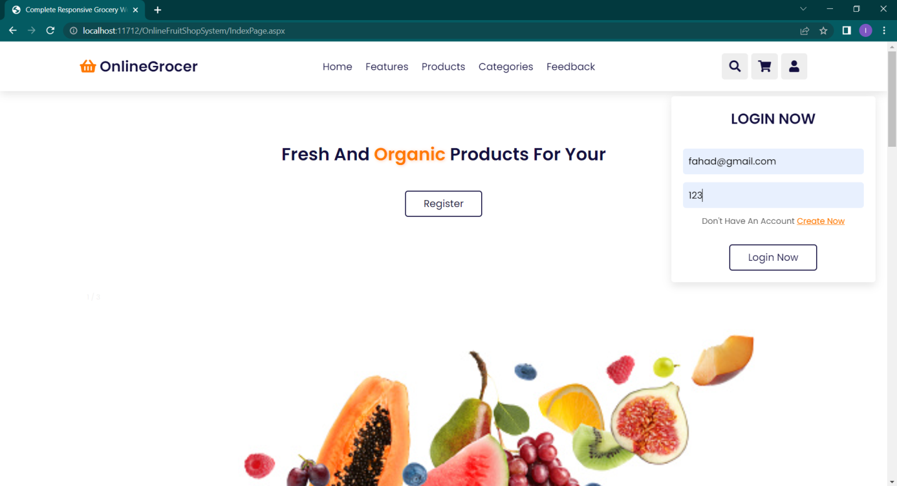

**Home Page:-**

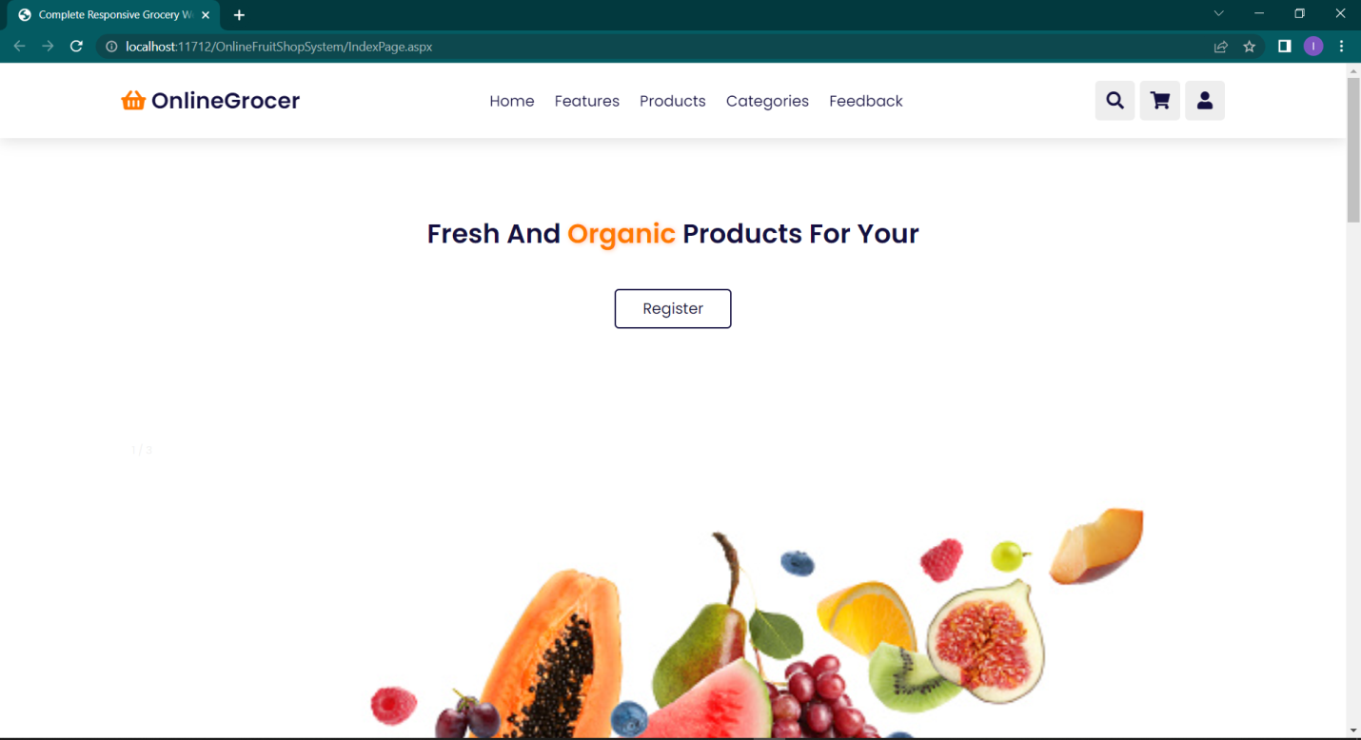

**Feature page:-**

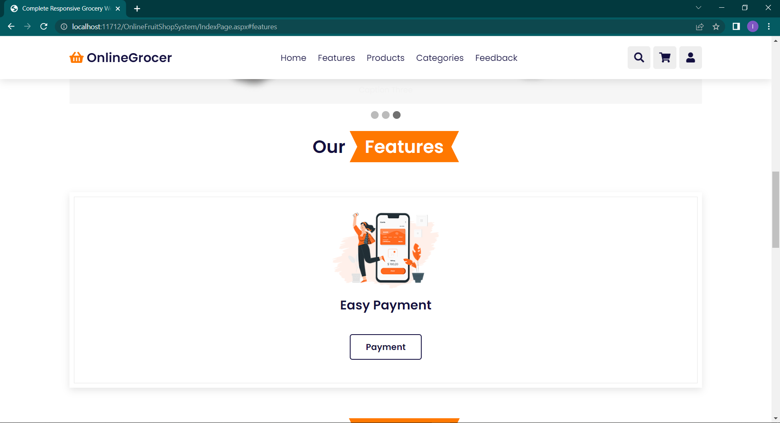

**Product page:-**

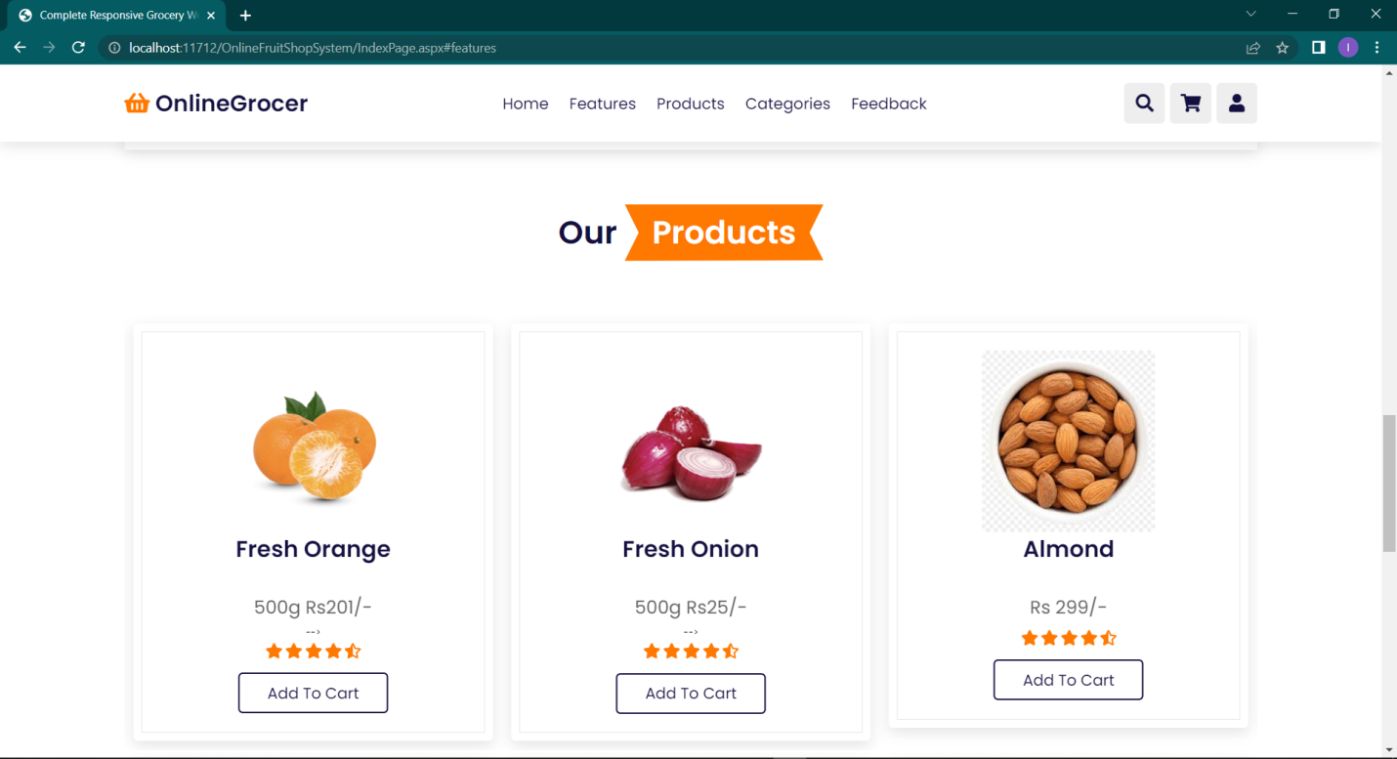

**Categories page:-**

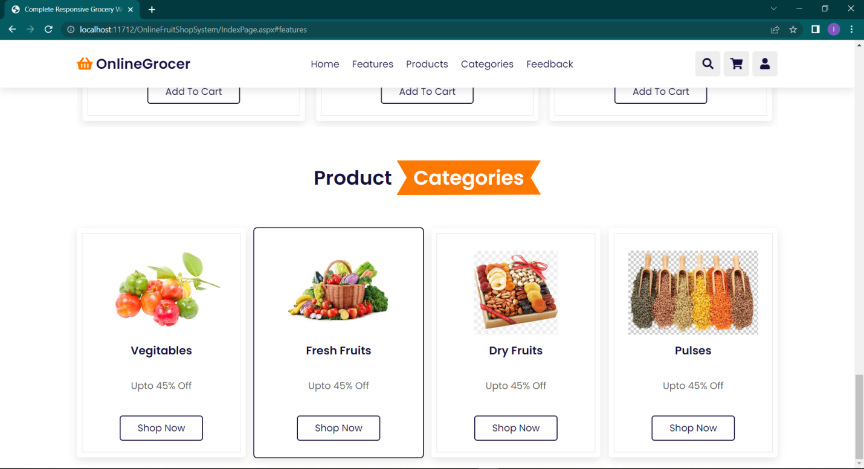

**Feedback page:-**

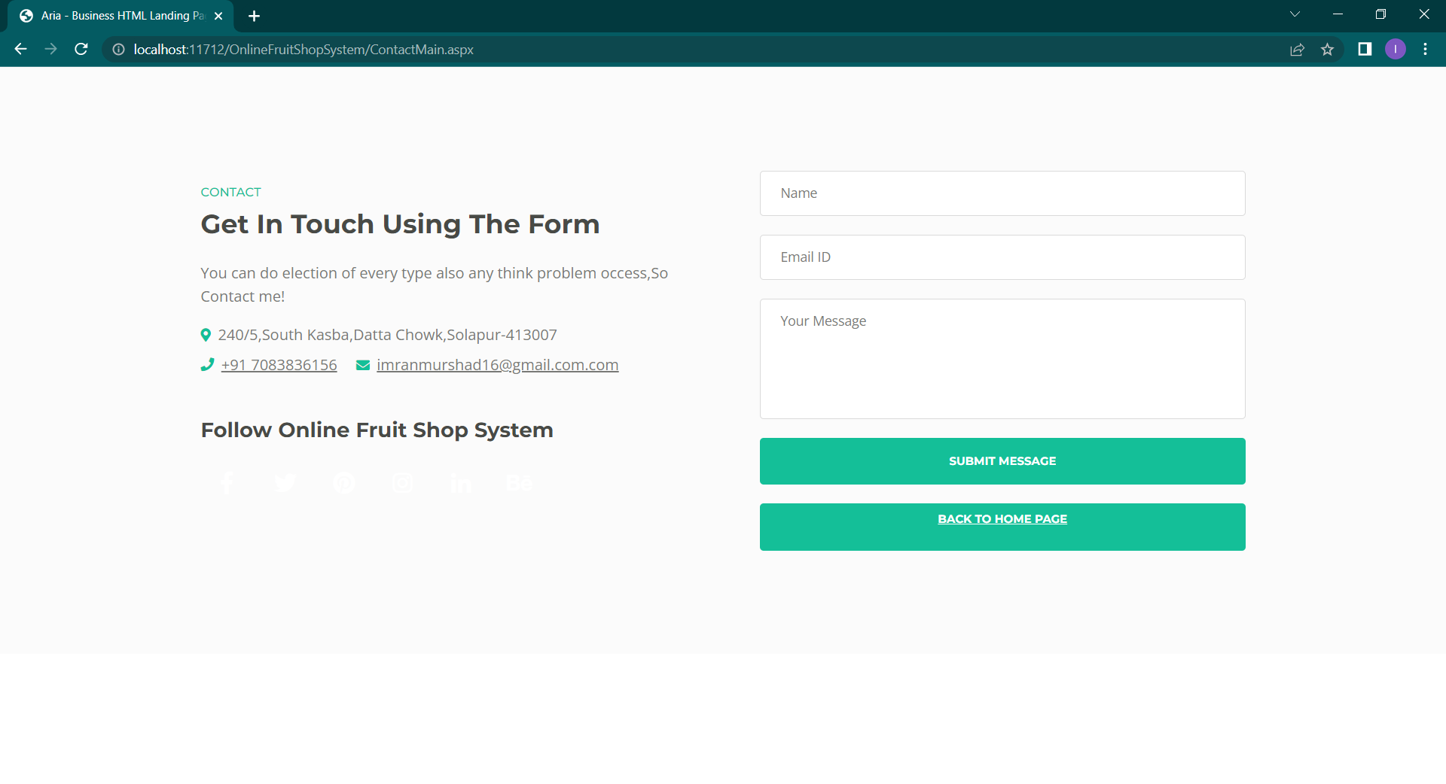

**Register page:-**

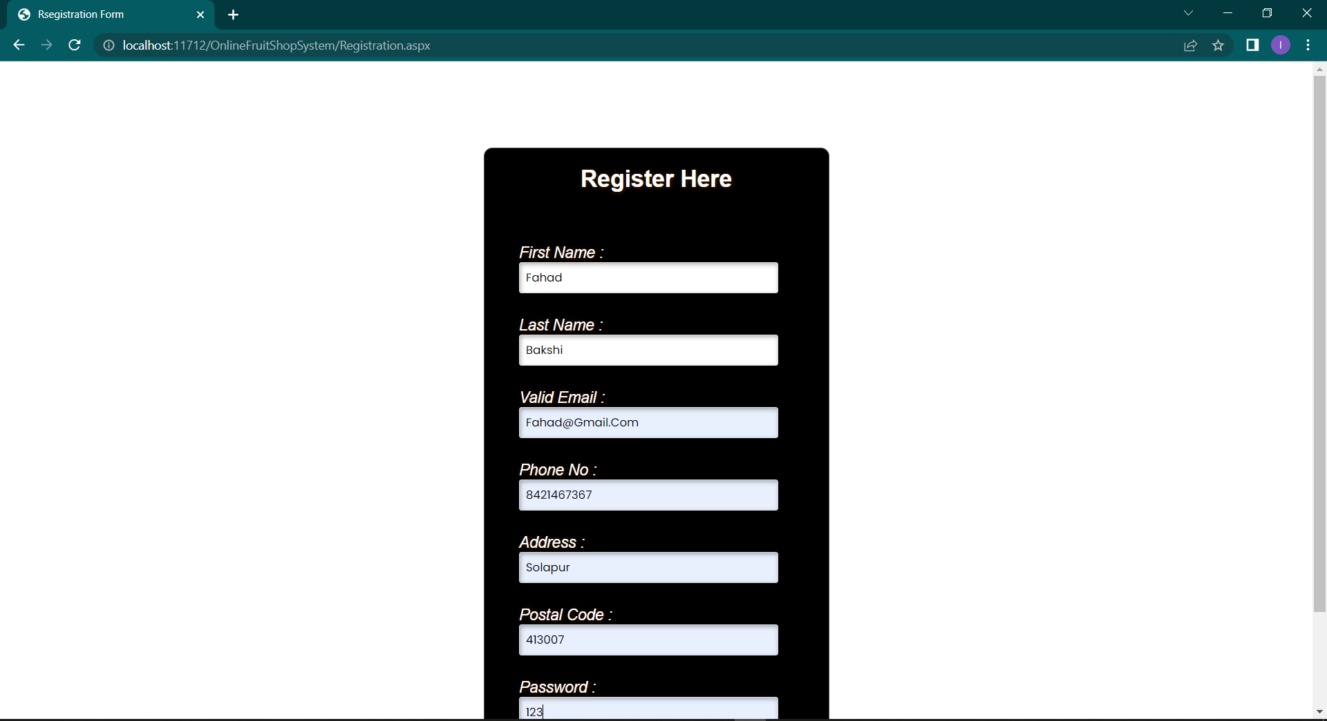

**Cart page:-**

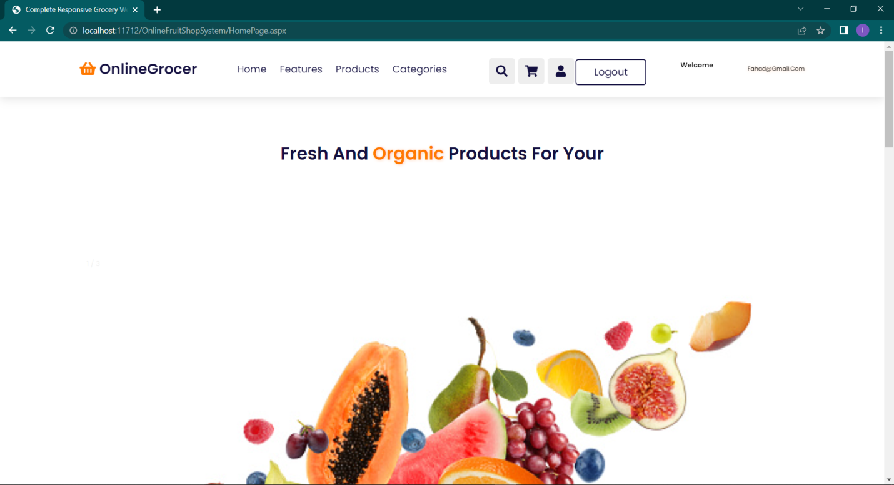

**Print Rceipt:-**



**Data base:-**

